**Aim:** Use Atlassian Jira project management tool to prepare schedule and do the estimation for

             the project using FP estimation technique and COCOMO estimation method

**Theory:**

**1.Cost Estimation Techniques**

Cost estimation is a set of techniques and procedures used to arrive at a cost estimate. These techniques are utilised by the process of cost estimation to compute the output from the given set of inputs. The inputs to the process of cost estimation are also called as cost drivers and the outputs are expressed in the form of efforts, duration, loading, or modified requirements to name a few.

**Functional Points:**

A function point is a unit of measurement to express the amount of business functionality an [information system](http://en.wikipedia.org/wiki/Information_system) (as a product) provides to a user. The cost (in dollars or hours) of a single unit is calculated from past projects.

Important Factors to be considered for FP are:

**Number of external inputs** – from user or another application

**Number of external inquiries** – request from user that generates an on-line output (E.G. IRCTC)

**Number of external outputs**

**Number of internal logical files** (maintained by system)

**Number of external interface files**

**Transactional Functional Type:**

**External Input (EI):** EI processes data or control information that comes from outside the application’s boundary. The EI is an elementary process.

**External Output (EO):** EO is an elementary process that generates data or control information sent outside the application’s boundary.

**External Inquiries (EQ):** EQ is an elementary process made up of an input-output combination that results in data retrieval.

**Internal Logical File (ILF):** A user identifiable group of logically related data or control information maintained within the boundary of the application.

**External Interface File (EIF):** A group of user recognizable logically related data allusion to the software but maintained within the boundary of another software.

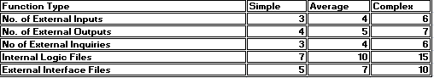

Figure 1: FP Table

FP Calculation for Project:

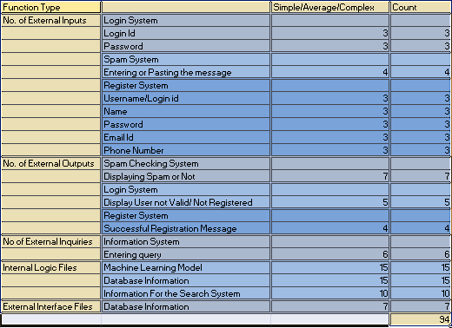

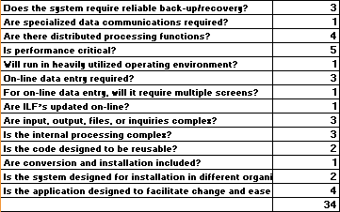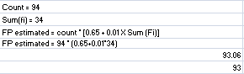

**COCOMO Model:**

Cocomo (Constructive Cost Model) is a regression model based on LOC, i.e number of Lines of Code. It is a procedural cost estimate model for software projects and often used as a process of reliably predicting the various parameters associated with making a project such as size, effort, cost, time and quality. It was proposed by Barry Boehm in 1970 and is based on the study of 63 projects, which make it one of the best-documented models.

The key parameters which define the quality of any software products, which are also an outcome of the Cocomo are:

Effort: Amount of labor that will be required to complete a task. It is measured in person-months units.

Schedule: Simply means the amount of time required for the completion of the job, which is, of course, proportional to the effort put. It is measured in the units of time such as weeks, months.

Categories of COCO Model:

**Organic –** A software project is said to be an organic type if the team size required is adequately small, the problem is well understood and has been solved in the past and also the team members have a nominal experience regarding the problem.

**Semi-detached –** A software project is said to be a Semi-detached type if the vital characteristics such as team-size, experience, knowledge of the various programming environments lie in between that of organic and Embedded.

**Embedded –** A software project with requiring the highest level of complexity, creativity, and experience requirement fall under this category. Such software requires a larger team size than the other two models and also the developers need to be sufficiently experienced and creative to develop such complex models.

Types of COCOMO:

**Basic COCOMO**:

It can be used for quick and slightly rough calculations of Software Costs. Its accuracy is somewhat restricted due to the absence of sufficient factor considerations.

The below formula is used for the cost estimation of the basic COCOMO model.

E=a(KLOC)b

**Intermediate COCO:**

The basic Cocomo model considers that the effort is only a function of the number of lines of code and some constants calculated according to the various software systems. The intermediate COCOMO model recognizes these facts and refines the initial estimates obtained through the basic COCOMO model by using a set of 15 cost drivers based on various attributes of software engineering.

.Classification of Cost Drivers and their attributes:

**Product attributes –**

Required software reliability extent

Size of the application database

The complexity of the product

**Hardware attributes**

Run-time performance constraints

Memory constraints

The volatility of the virtual machine environment

Required turnabout time

**Personnel attributes**

Analyst capability

Software engineering capability

Applications experience

Virtual machine experience

Programming language experience

**Project attributes**

Use of software tools

Application of software engineering methods

Required development schedule

COCOMO Calculation For Project:

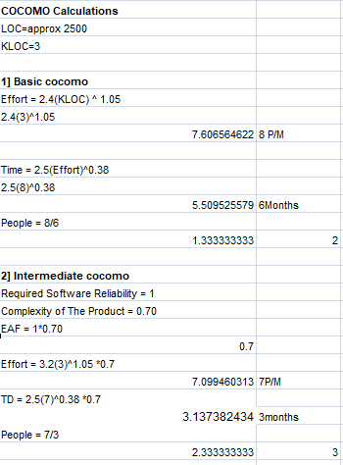

**2.Description about timeline chart and design timeline chart (For Project)**

**Description:** A Timeline is a chart which displays a project plan schedule in chronological order. A Timeline is used in project management to depict project milestones and visualize project phases, and show project progress. The graphic form of a timeline makes it easy to understand critical project milestones, such as the progress of a project schedule. Timelines are particularly useful for project scheduling or project management when accompanied with a Gantt chart. It captures the main of what the project will accomplish and how it will be done. making a project timeline is one of the most important skills a project manager needs have.

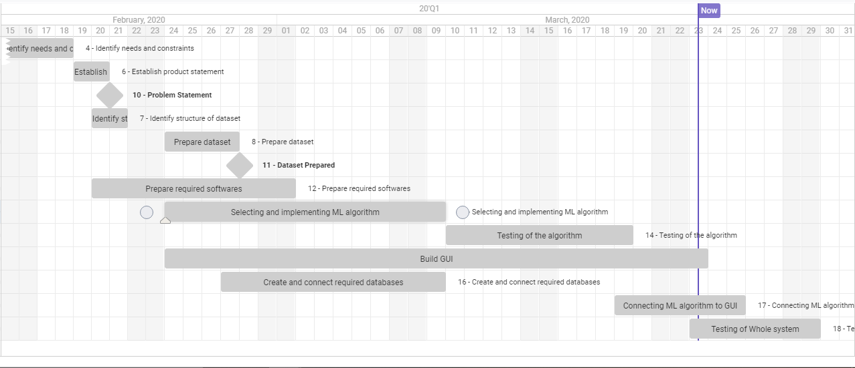

FIG 2: Timeline chart for Spam Detection System using Atlassian Jira.

Timeline Chart In Microsoft Word:

|  |  |  |  |  |  |  |
| --- | --- | --- | --- | --- | --- | --- |
| **Work Task** | **Week1** | **Week2** | **Week3** | **Week4** | **Week5** | **Week6** |
| Identify needs and constraints |  |  |  |  |  |  |
| Establish product statement  Milestone: Product statement |  |  |  |  |  |  |
| Identify structure of dataset |  |  |  |  |  |  |
| Prepare dataset  Milestone: Dataset prepared |  |  |  |  |  |  |
| Prepare required soft wares |  |  |  |  |  |  |
| Selecting and implementing ML algorithm |  |  |  |  |  |  |
| Testing of the algorithm |  |  |  |  |  |  |
| Build GUI |  |  |  |  |  |  |
| Create and connect required databases |  |  |  |  |  |  |
| Connecting ML algorithm to GUI |  |  |  |  |  |  |
| Testing of Whole system |  |  |  |  |  |  |

**3.Description about WBS and Design WBS (For Project)**

A **Work Breakdown Structure** includes dividing a large and complex project into simpler, manageable and independent tasks. The root of this tree (structure) is labelled by the Project name itself. For constructing a work breakdown structure, each node is recursively decomposed into smaller sub-activities, until at the leaf level, the activities becomes undividable and independent. It follows a Top-Down approach.

**Steps:**

* **Step-1:** Identify the major activities of the project.
* **Step-2:** Identify the sub-activities of the major activities.
* **Step-3:** Repeat till undividable, simple and independent activities are created.

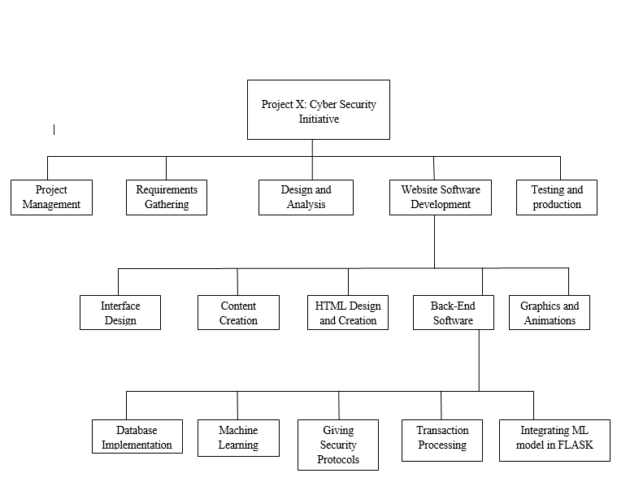

**CONCLUSION:**

From this experiment, we were introduced to concept of project estimation for the software. There are multiple ways like FP(Function Point) estimation and COCOMO that is constructive cost model estimation. We made project cost estimation using both techniques for or software project. Later we understood concepts of timeline chart and Work Breakdown Structure. We implemented Timeline chart in Atlassian Jira and also in Microsoft Word. We also made WBS or Work Breakdown Structure for the project.